Tanmay Pandey | Roll No-69 | Sec-A

# pwd

Displays the current working directory.

# ls

Lists files in the current directory.

# ls -la

Lists all files, including hidden ones, with detailed info.

# cd

Changes to a different directory.

# cd ..

Moves to the parent directory.

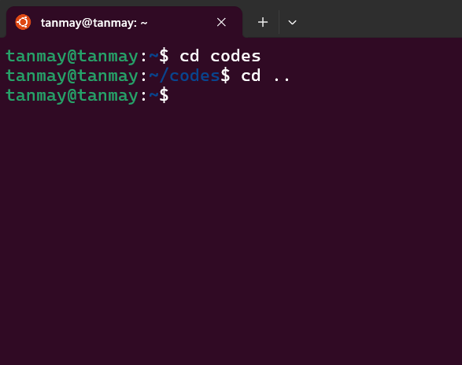

# cd ~

Moves to the home directory.

# mkdir

Creates a new directory.

# rmdir

Removes an empty directory.

# rm -r

Removes a directory and its contents.

# find . -name "*.txt"

Finds all .txt files in the current directory.

# touch

Creates an empty file.

# cp

Copies a file.

# cp -r

Copies a directory and its contents.

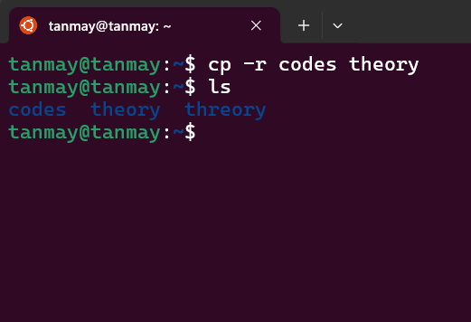

# mv

Moves or renames a file.

# rm

Deletes a file.

# cat

Displays the contents of a file.

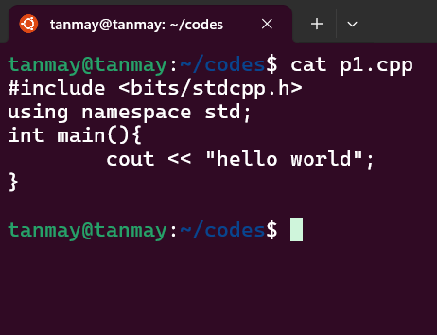

# more

Displays the contents of a file page by page.

# head

Shows the first 10 lines of a file.

# tail

Shows the last 10 lines of a file.

# nano

Opens a file for editing in the nano text editor.

# chmod +x

Makes a file executable.

// however my cpp file wont exe as it would execute a script only

# chmod 755

Changes file permissions to 755.

// 7-> owner given read(4),write(2),exeute(1)

//5->group given read and exe

//5->others given read and exe

# chgrp

Changes the group ownership of a file.

# umask

Sets default permissions for newly created files.

// new file created will have unrestricted access to the owner and write only for grps and users

# ls -l

Lists files with permissions and ownership.

# getfacl

Displays access control lists (ACLs) for files.

# setfacl

Sets ACLs for files.

# stat

Displays detailed file information, including permissions.

# find . -perm 777

Finds files with specific permissions.



# grep

Searches for patterns in files.



# sed

Stream editor for modifying files.

# awk

Text processing tool for columns and patterns.

// prints first col

# cut

Cuts sections from files based on delimiters.

# sort

Sorts lines in a file.

# uniq

Removes duplicate lines from a file.

// removes only consecutive ele

# tr

Translates characters.

# wc

Counts words, lines, and characters in a file.

# tee

Writes output to both a file and stdout.

# xargs

Builds command lines from input.

// execute echo for each line



# ping

Tests connectivity to a server.

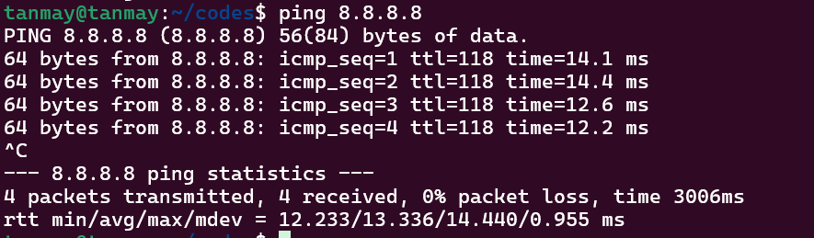

# ifconfig

Displays network interface configuration.

# ip addr

Displays IP addresses of network interfaces.

# netstat

Shows network connections.

# wget

Downloads a file from the internet.

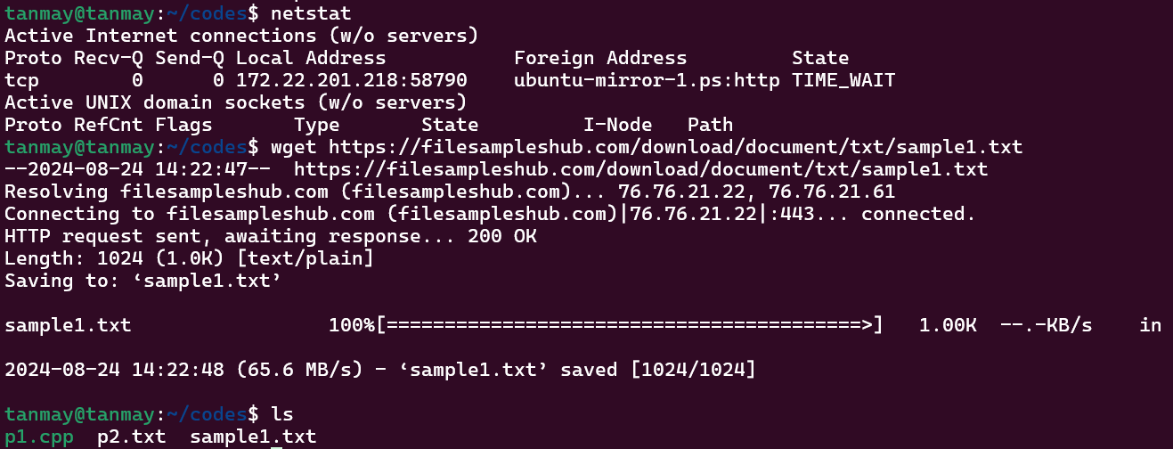

# curl

Transfers data from or to a server.

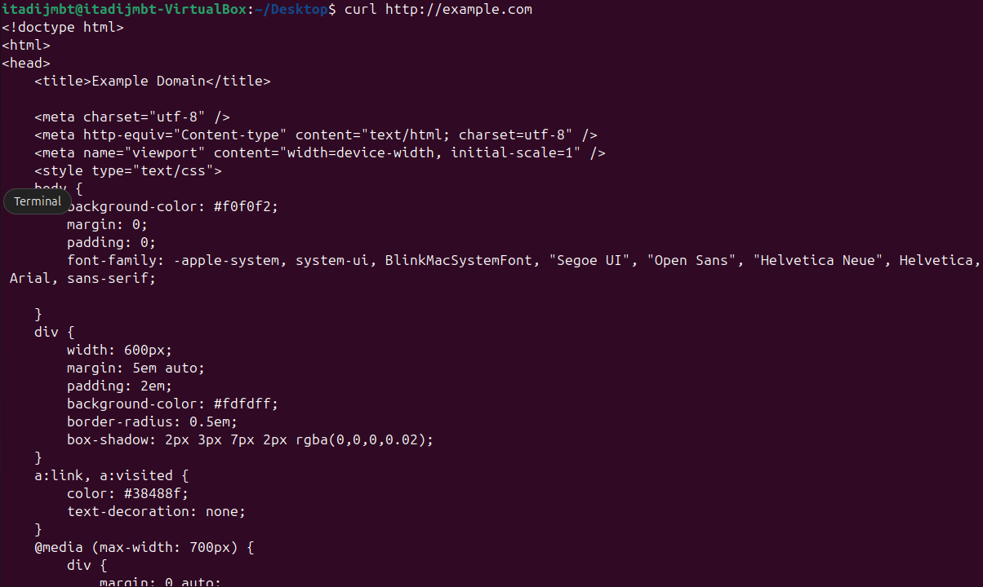

# scp

Securely copies files between hosts.



# ssh

Connects to a remote server via SSH.

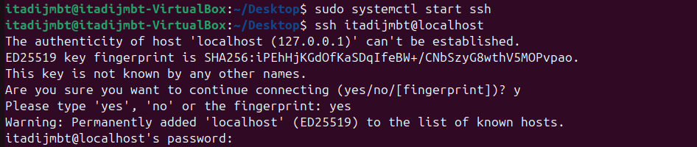

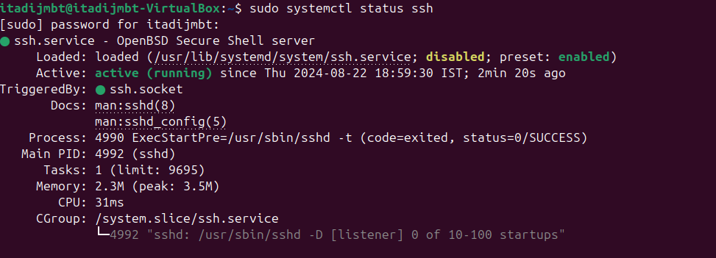

# host

DNS lookup for an IP address.

# nslookup

Queries DNS to find domain information.

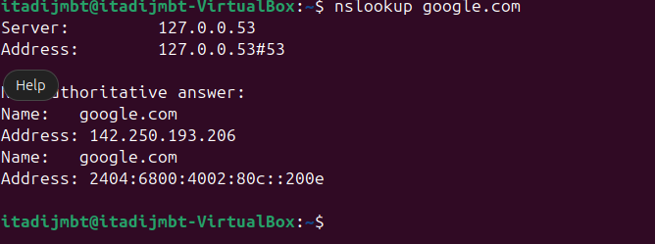

# df

Shows disk space usage.

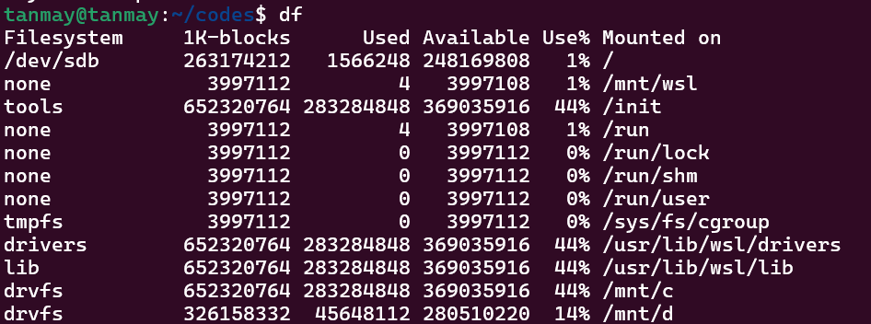

# du

Displays disk usage of a directory.



# mount

shows a list of all filesystems mounted on your system and their mount points

# Sudo apt install [filename]

attempts to install a package using the **Advanced Package Tool** package manager on linux sys

# fsck

Checks and repairs filesystems.

// should be done on unmounted sys to prevent data corruption

# lsblk

list all available storage devices on your system

# sudo fdisk -l

commands will show a list of all connected block devices (disks, partitions)

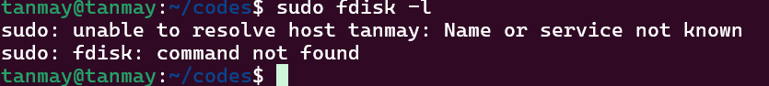

# blkid

Shows block device attributes.

# df

# sync

command forces any data that is still in memory (buffers/cache) to be written to the disk immediately

# ps

Lists running processes.

# top

Real-time process monitoring.

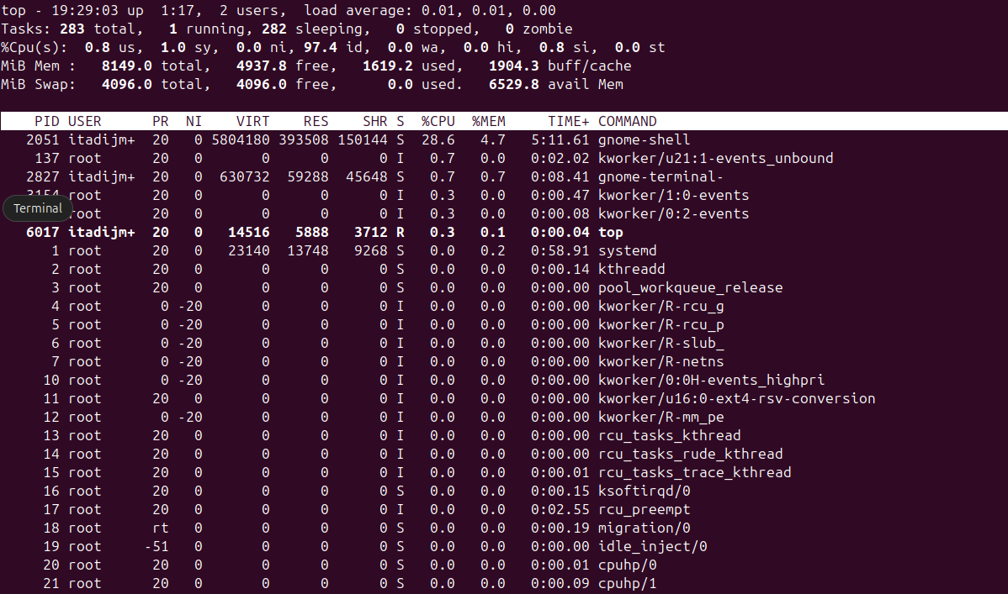

# htop

Enhanced version of top.

//install htop first

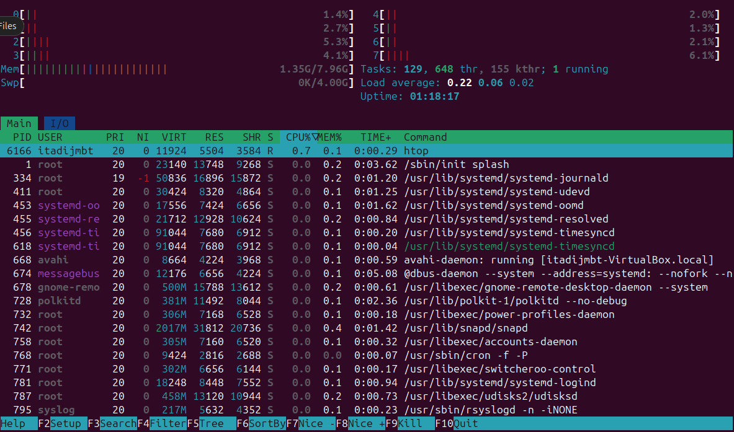

# kill

Terminates a process by PID.

//3346 for firefox

# killall

Terminates processes by name.

//bfore firefox was opened

# pkill

Sends signals to processes.

//before

# nice

Runs a process with a modified priority.

// compressing can take a lot of so setting custom priority

# renice

Changes the priority of a running process



# jobs

Lists background jobs.

// no background jobs

# bg

Resumes a job in the background.

# uname -a

Displays system information.



# uptime

Shows system uptime.



# who

Displays who is logged in.

# free

Shows memory usage.

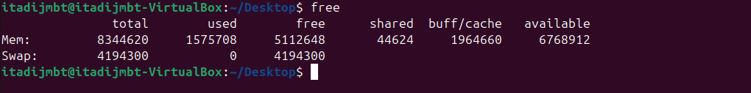

# vmstat

Displays virtual memory statistics.



# iostat

Displays CPU and I/O statistics.

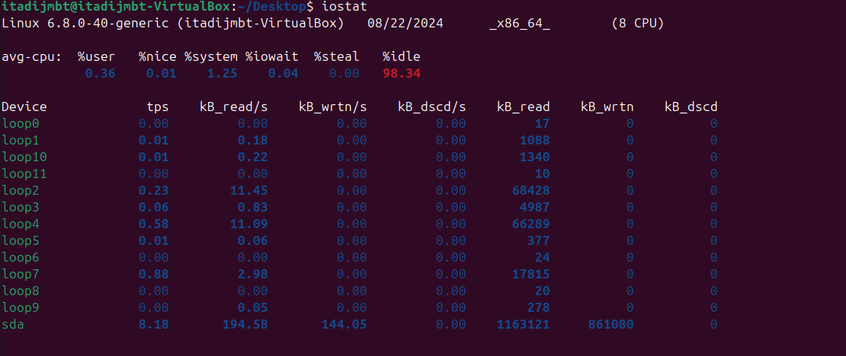

# dmesg

Displays boot and system messages.



# lscpu

Displays CPU architecture info.

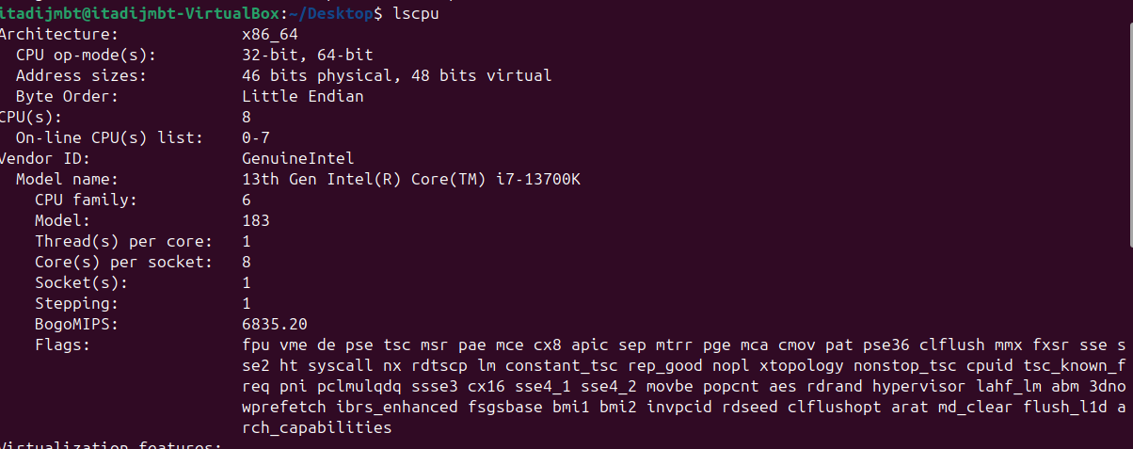

# lsusb

Lists USB devices.



# lspci

Lists PCI devices.

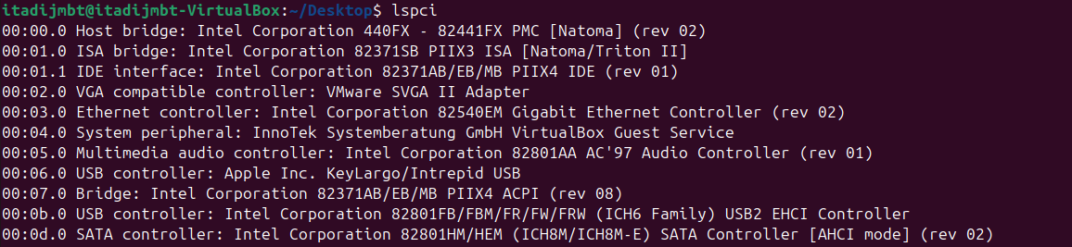

# tar -cvf

Creates a tar archive.

# tar -czf

Extracts a tar archive.(tape archieve)

c->tells to create a new arc

z->compress using gzip

f->new name

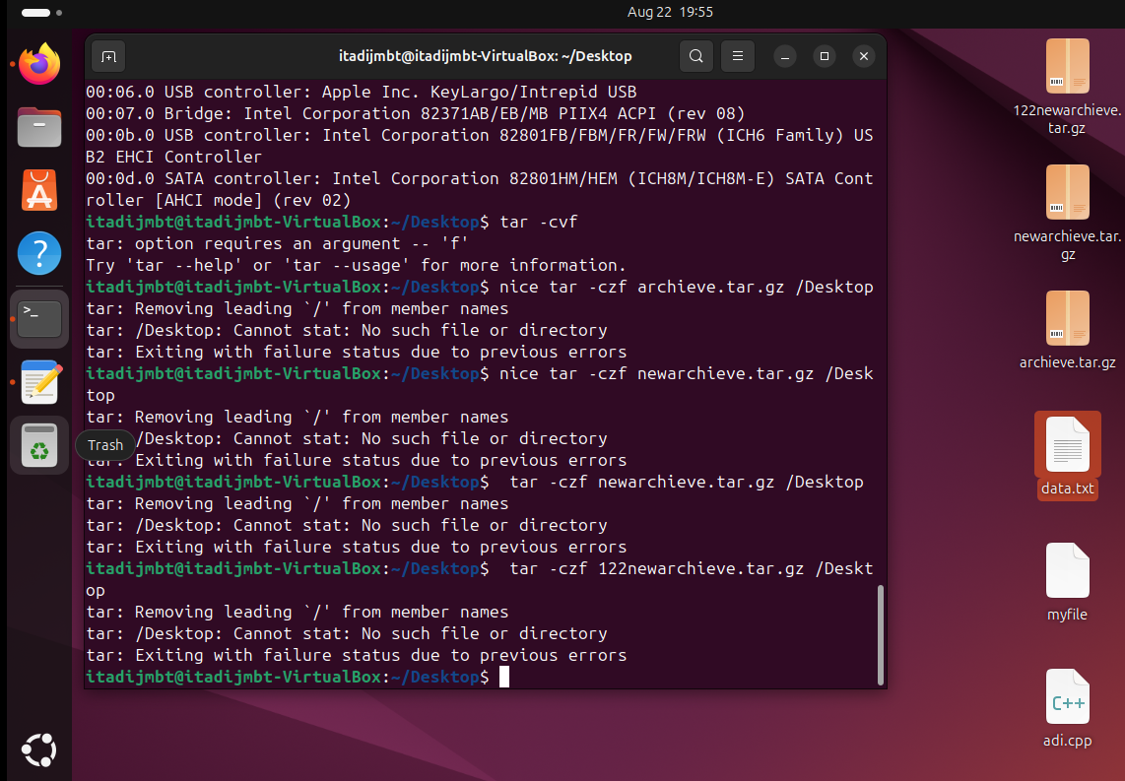

# gzip

Compresses a file using gzip.

//first created a new tar as newtest .tar and then compressed it

# gunzip

Decompresses a gzip file.

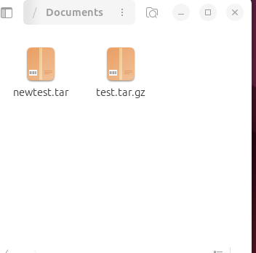

The old .tar.gz file us uow unzipped

# zip

Creates a zip archive.

# unzip

Extracts a zip archive.

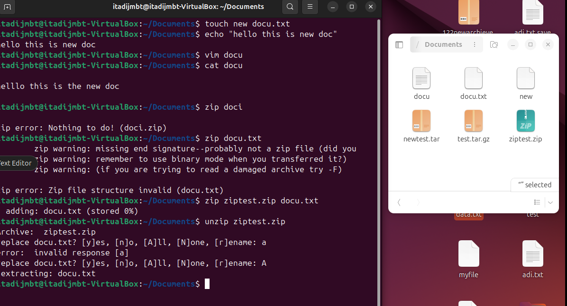

# bzip2

Compresses a file using bzip2.

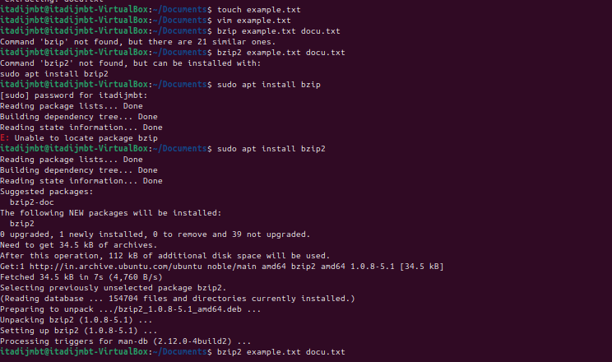

# bunzip2

Decompresses a bzip2 file



# xz

Compresses a file using xz.

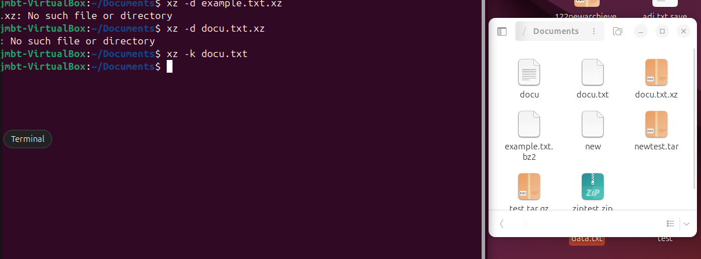

# unxz

Decompresses an xz file.

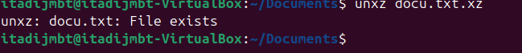

# apt update

Updates package lists (Debian/Ubuntu).

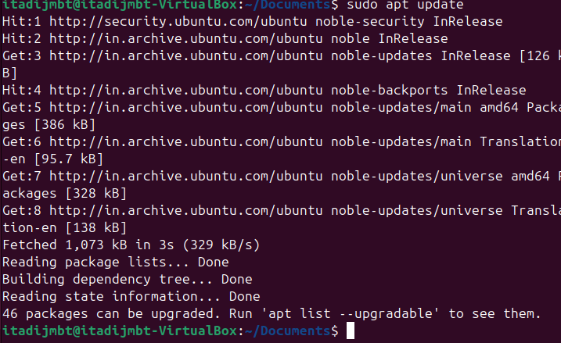

# apt upgrade

Upgrades all installed packages (Debian/Ubuntu).

# apt install

Installs a new package (Debian/Ubuntu).

# apt remove

Removes a package (Debian/Ubuntu).

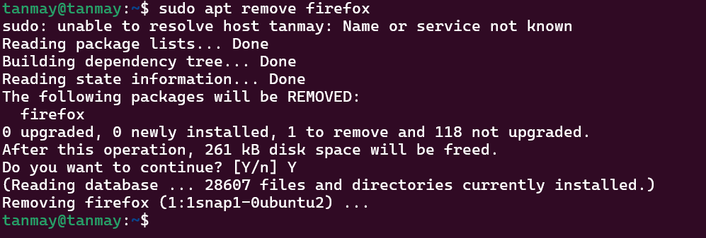y

ty

# apt autoremove

Removes unused packages.



# dnf install

Installs a package



# Apt list --installed

List of installed items

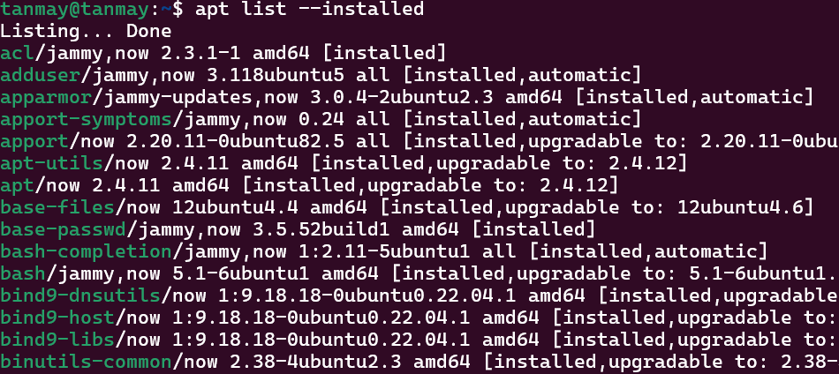

# Sudo apt autoclean

To remove package files that are no longer needed

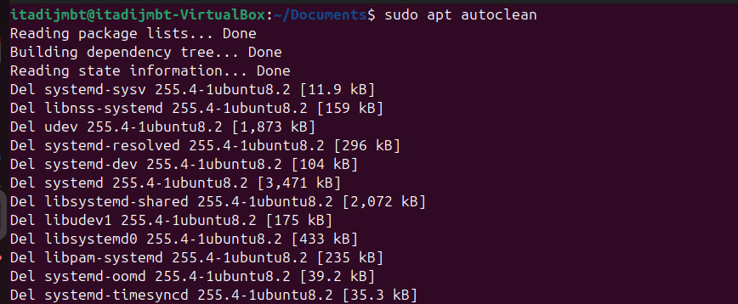

# flatpak update

update all installed Flatpak packages to their latest versions

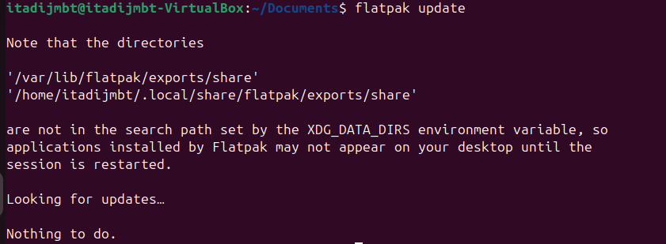

# flatpak list

update all installed Flatpak packages to their latest versions

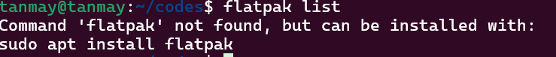

Apt Search

// searches for applet

